Glide Configuration
- Main Tables
Tables | Purpose
Design Request | Stores all customer requests and workflow Information
Staff Members | Stores staff accounts and roles
Draft Notification | Stores all draft notifications records
Revision History | Stores revision tracking information
Approval Notification | Stores approval notifications
Revision Notifications | Stores revision alerts
Design Request Dashboard | Shows dashboard metrics and reporting

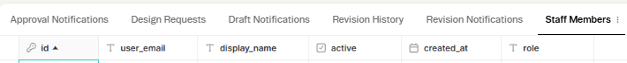
Figure 1: Design Request table configured in Glide.
Figure 2: Staff member table configured in Glide
Figure 3: Revision history table configured in Glide
Figure 4: Approval Notification table configured in Glide
Figure 5: Revision Notification table configured in Glide 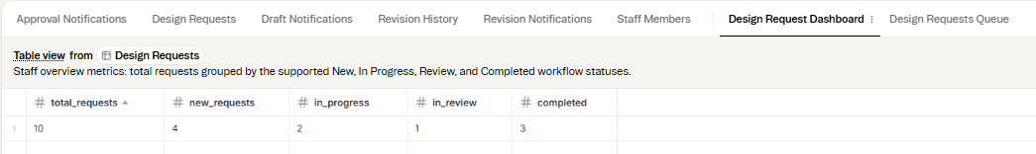
Figure 6: Design Request dashboard table configured in Glide
- Design Request Table
Key fields:
Field | Description
Project_id | Unique Identifier for each project
Customer_name | Name of customer
Design_request | Type of service requested
Requirements | Customer specifications
Status | Current workflow status
Revision_count | Number of revisions requested
Approval_status | Customer approval status

Evidence:
See 03_Prototype/Glide_Screenshots/Design_Requests_Table.png
- User Roles and Permissions
Role | Permission
Customer | Submit request, review drafts, track status, approve projects
Staff member | View assigned requests, update status, upload drafts.
Owner | Full access to records, dashboards and workflow management.

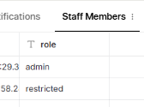

Security Consideration
Role- based access is used to restrict users from accessing functions that are not relevant to them. Staff member is restricted from accessing customer-facing service portal , while customers can only access information relating to project request and project.

Workflow Configuration
The system supports the following workflow:
NEW REQUEST

IN PROGRESS
DRAFT READY

CUSTOMER REVIEW

REVISION REQUETED (Optional )

REVISED DRAFT

APPROVED

COMPLETED

Customer submits a new request, after which the staff begins the design and change status to In progress. The staff then uploads the drafts and allows the customer to review it. If changes are required, the customer request a revision highlighting the changes which is recorded in the revision history and triggers a revision notification to the staff member. If no further changes are required, the final product is sent for approval. Once the customer approves the final product, the staff changes the project status to completed.

Workflow Actions.
The following Glide action was configured to support the workflow:
User action: customer selects Submit Request
Result: A new design request record is created and stored in the design request table for processing and tracking
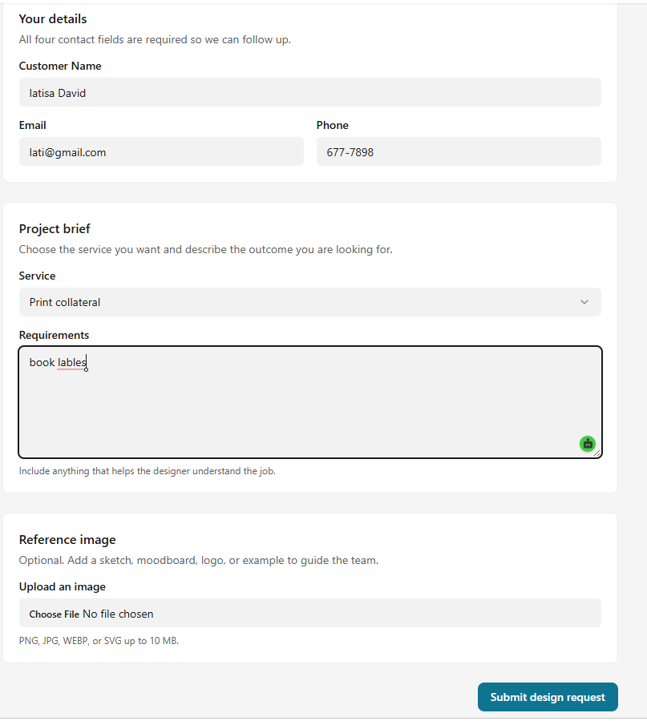

Figure 7a: customer submitting design request
Figure 7b. table showing data being stored in the design request table.
Figure 7a and 7b : Glide action configured to create a new design request when the customer submits a request.

User action: customer select approved design and submit feedback.
Result: The Approval_Status field is updated to Approved and the project can be marked as completed.

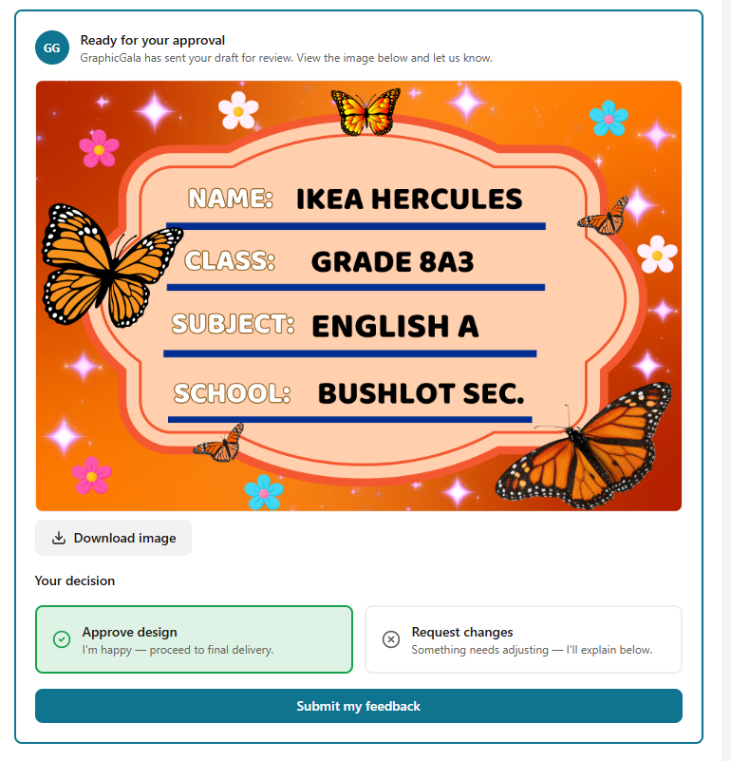
Figure 8a: Showing customer approving the design and submitting the feedback
Figure 8b: record is added and approval status changed to Approve
Figure 8a and 8b: glide action configured to update approval status after customer approved a design.
- Dashboard Configuration
The dashboard provides summary metrics generated from the Design Requests Tables.
Metrics Displayed
- Total Request
- New Requests
- In progress Request
- Requests in Review
- Completed Request
The dashboard enables staff to monitor workload and track request progression.
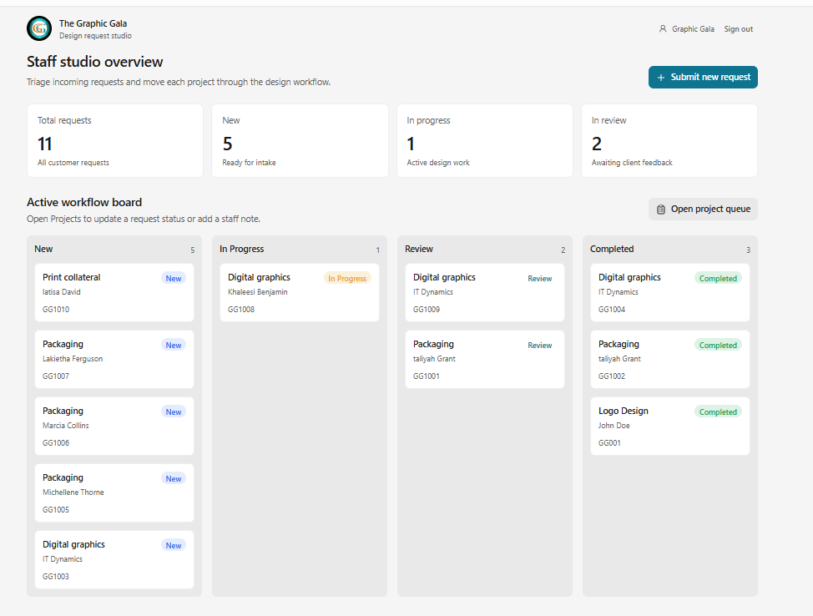
Figure 9: Image showing the dashboard.

- Data Relationship
The design request table serves as the primary table for customer projects. Related tables such as drafts notification, revision history, approval notification and revision notification are linked to design request using the project id field. These relationships allow workflow information and notifications to be associated with the appropriate design request.

